Product List
For SKU Start From:

Product Model | Image Sample |  | Unit Price | QTY
ONV-H1016PL  18 port 10/100M unmanaged poe switch (200W) | 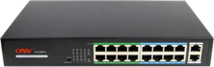  SKU: NS1000 | 1) 16*10/100M poe ports,802.3af/at+2*10/100/1000M RJ45 ports  - Max power per poe port:30W.  - Port 9-16 support 10M@long transmission distance 250 meters and VLAN optional  - Supply power with the spare line pair (1,2(+)/3,6 (-)method default； 4,5(+)/7,8(-)optional  - Built-in power supply | $125.00 | 2 | Do not mark up
ONV-H1024PL  26 port 10/100M unmanged poe switch (total 250W) | SKU: NS1001  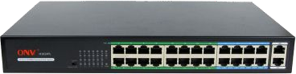 | 1) 24*10/100M RJ45 ports,802.3af/at+2*10/100/1000M RJ45 ports  - POE max power per port:30W  - POE port 17-24 10M@transmission distance 250 meters.  - Supply power with the spare line pair (1,2(+)/3,6 (-)method default； 4,5(+)/7,8(-)optional  - Built-in power supply | $148.00 | 2 | Do not mark up
ONV-H3108P  10 port 10/100/1000M unmanaged poe switch (total 120W) | SKU: NS1002  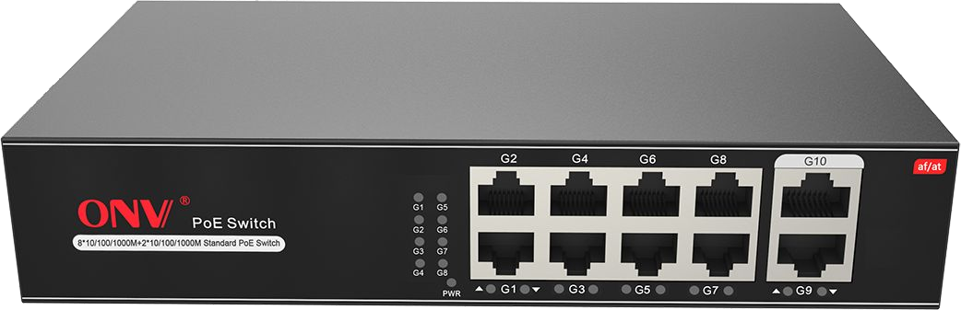 | 1) 8*10/100/1000M poe port,802.3af/at+2*10/100/1000M RJ45 port  - Max power per poe port:30W,total power:120W  - Port 1-8 support 10M@long transmission distance 250 meters and VLAN optional  - Supply power with the spare line pair (1,2(+)/3,6 (-)method default； 4,5(+)/7,8(-)optional  - Built-in power supply | $50.00 | 2 | Do not mark up
ONV-H3016PF  18 port gigabit unmanaged poe switch (200W) | SKU: NS103  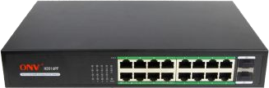 | 1)16*10/100/1000M poe ports,802.3af/at+2*1000M SFP fiber port  - Supply power with the spare line pair (1,2(+)/3,6 (-)method default； 4,5(+)/7,8(-)optional  - Built-in power supply  - Fiber module excluded | $151.00 | 2 | Do not mark up
ONV-H3024PF  26 port gigabit unmanaged poe switch (250W) | SKU: NS1004  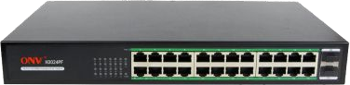 | 1) 24*10/100/1000M poe ports,802.3af/at+2*1000M SFP fiber port  - Supply power with the spare line pair (1,2(+)/3,6 (-)method default； 4,5(+)/7,8(-)optional  - Built-in power supply  - Fiber module excluded | $175.00 | 1 | Do not mark up
Click Me | SKU: UB1000 |  | $150 | 1 | Do not mark up
Click Me | SKU: UB1001 |  | $100 | 2 | Do not mark up
Click Me | SKU: UB1002 |  | $92 | 1 | Do not mark up
Click Me | SKU: UB1003 |  | $90 |  | Do not mark up

Model | Picture | Brief Description | Unit Price (EXW) | Qty(pcs)
ONV-H1108PL  10 port 10/100M unmanaged poe switch (total 120W) | SKU: NS1005  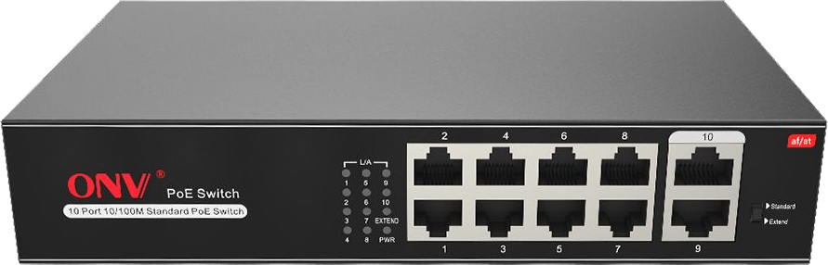 | 1) 8*10/100M poe port,802.3af/at+2*10/100M RJ45 port  - Max power per poe port:30W,total power:120W  - Port 1-8 support 10M@long transmission distance 250 meters and VLAN optional  - Supply power with the spare line pair (1,2(+)/3,6 (-)method default； 4,5(+)/7,8(-)optional  - Built-in power supply | $35.00 | 4 | Do not mark up

